Transformer Architecture
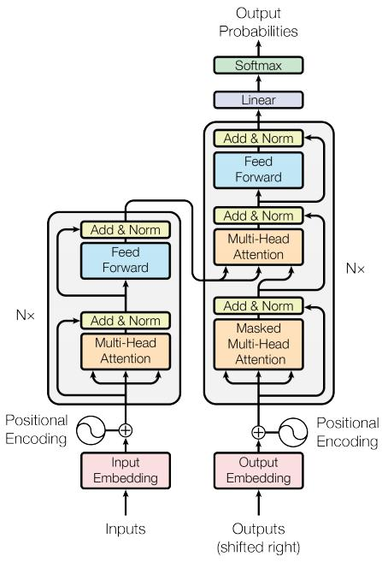
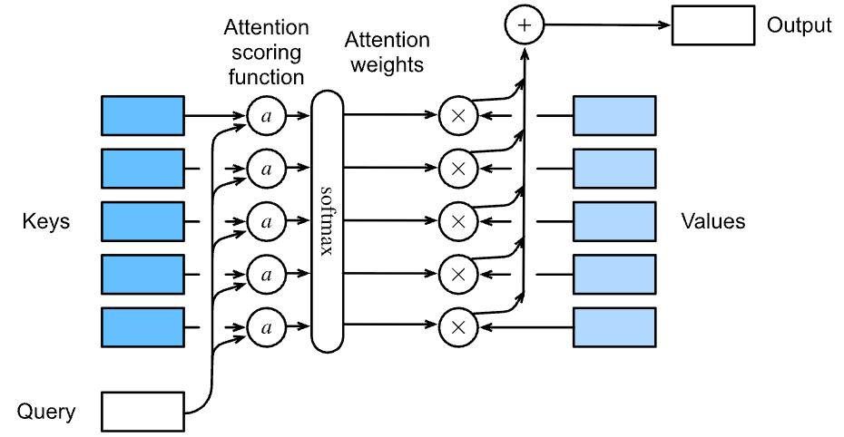
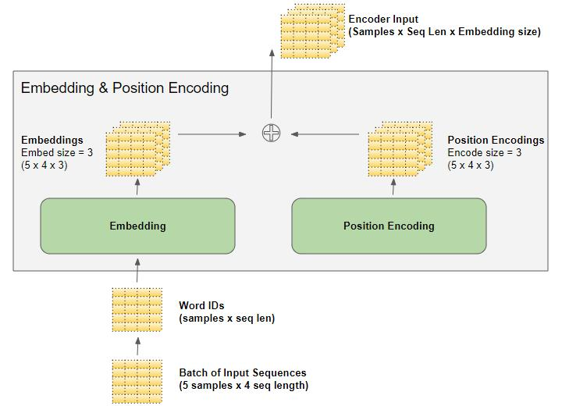
What it is
A deep learning architecture designed to process sequences (text, code, etc.) efficiently using attention instead of recurrence.
Key Components
- Input Embeddings – converts words into vectors
- Positional Encoding – adds order information
- Self-Attention Layer – understands relationships
- Feedforward Neural Network – processes features
- Output Layer – generates predictions
Why it matters
- Handles long context better
- Scales to large datasets
- Foundation of modern LLMs

Self-Attention Mechanism
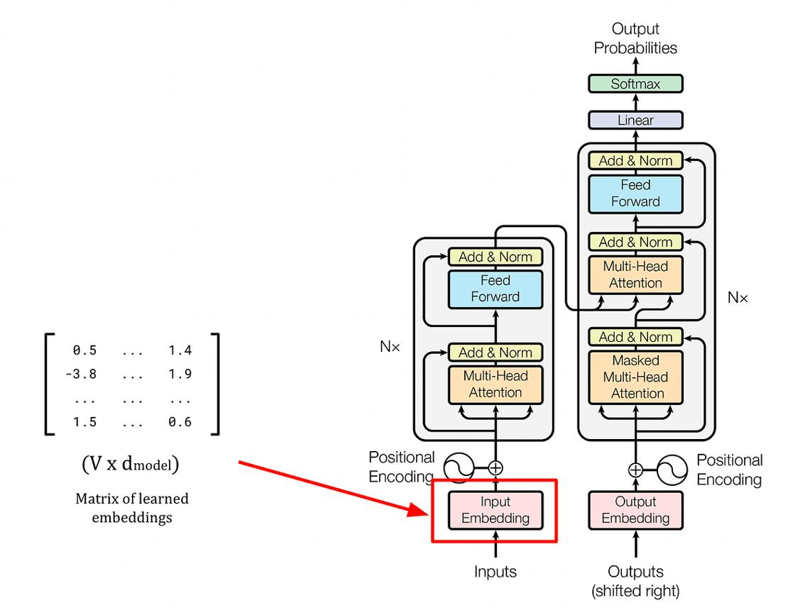
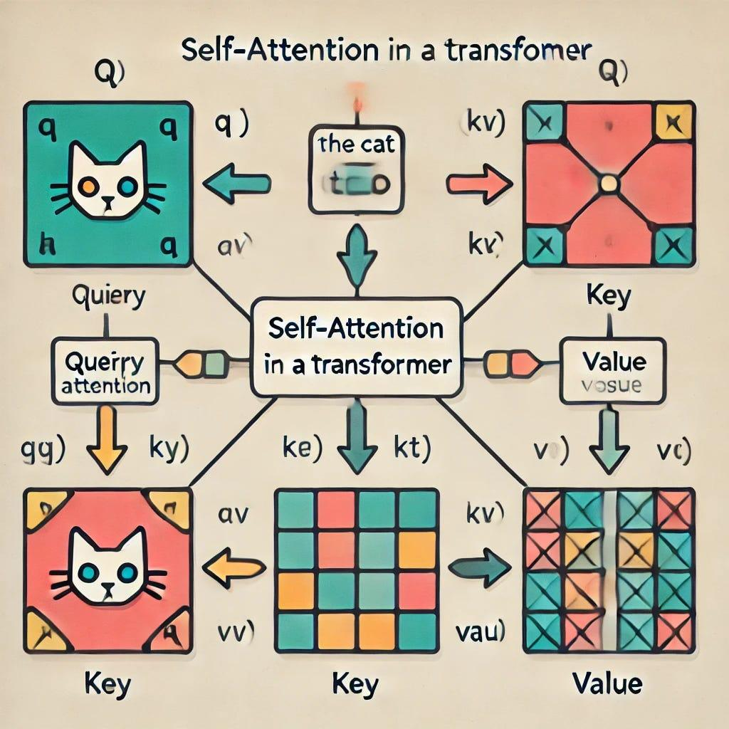
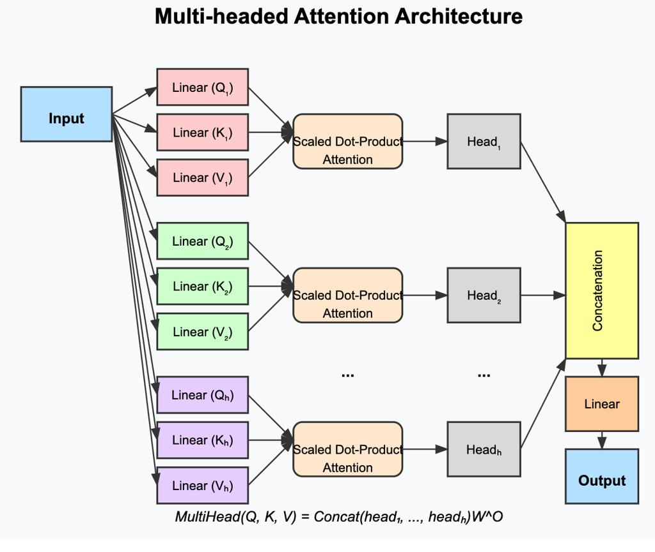
What it does
Allows each word to look at every other word in a sentence and decide what is important.
Example
Sentence:
"The bank near the river is closed"
- “bank” attends to “river” → meaning = river bank
- Not financial bank
Key Idea
Each word gets:
- Query (Q)
- Key (K)
- Value (V)
Attention = how relevant other words are

Tokenization Process
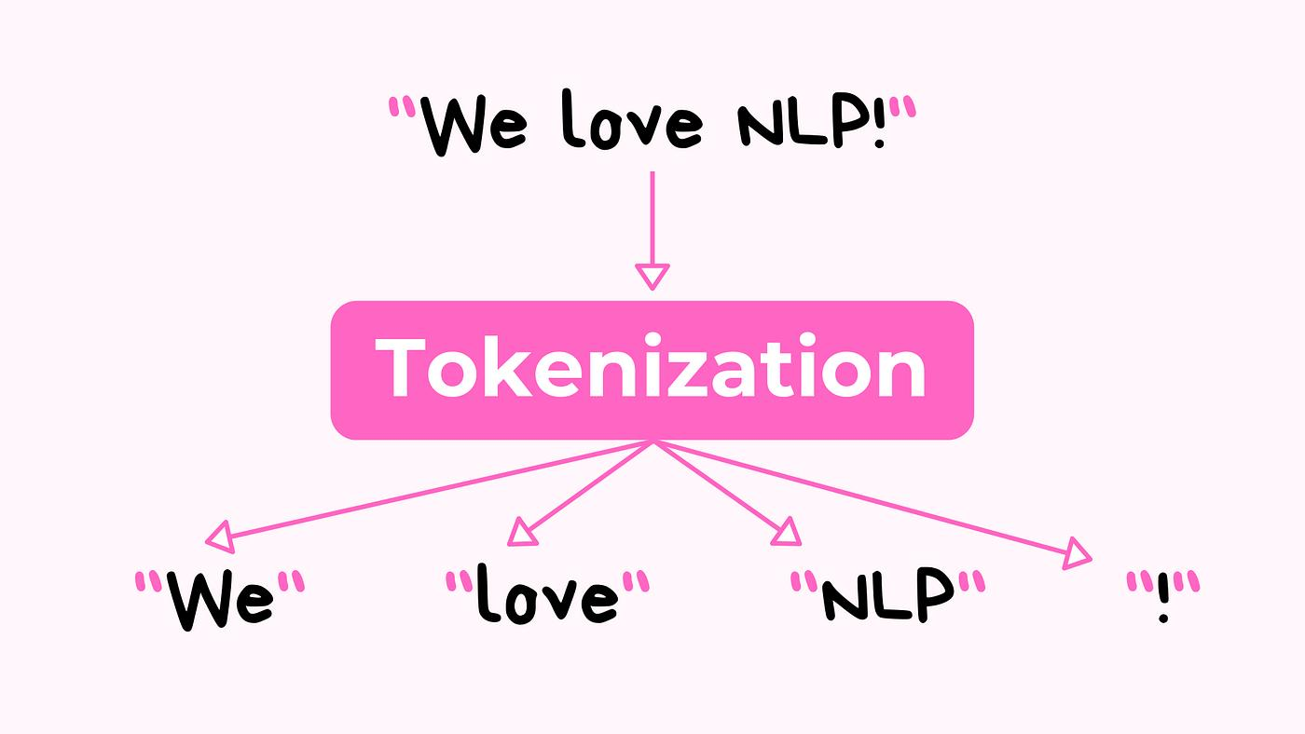
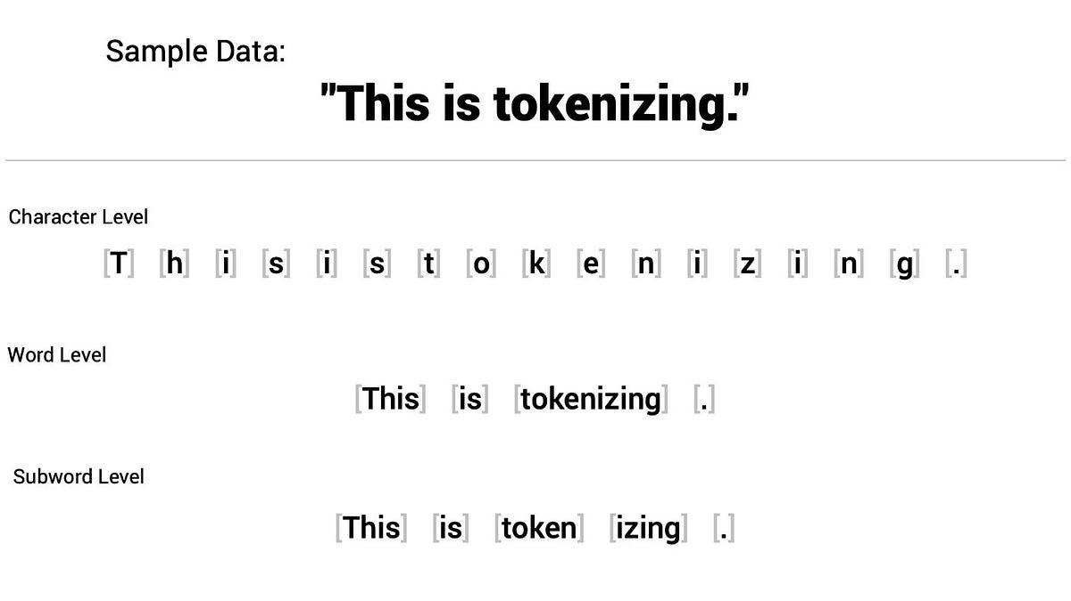
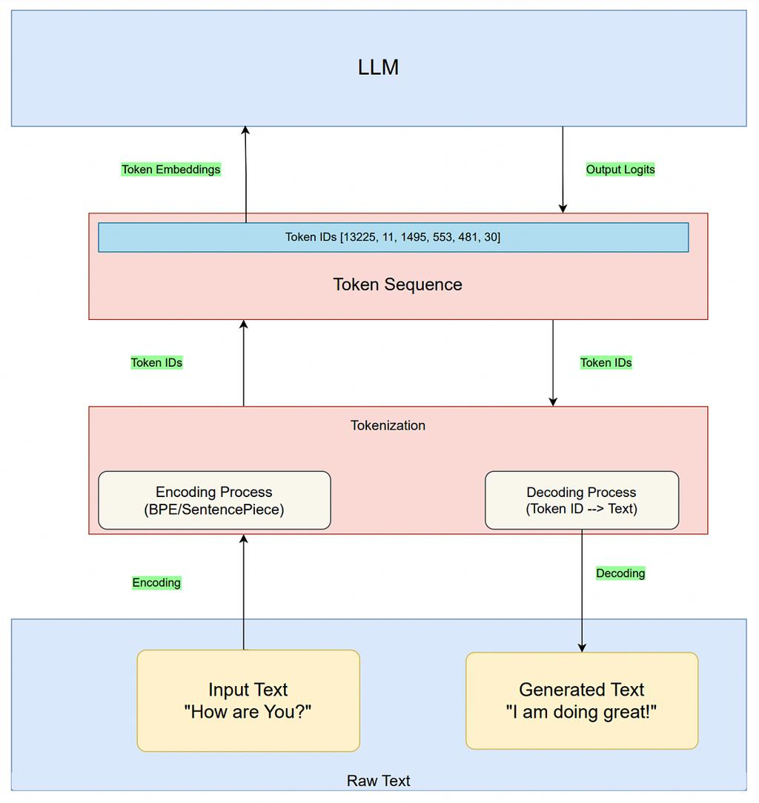
What it is
Breaking text into smaller units called tokens
Example
"Data Engineering is powerful"
→ ["Data", " Engineering", " is", " powerful"]
Important Points
- Tokens ≠ words
- Models process tokens, not raw text
- Token count impacts:
  - Cost
  - Speed
  - Context limit

Parallel Processing in Transformers
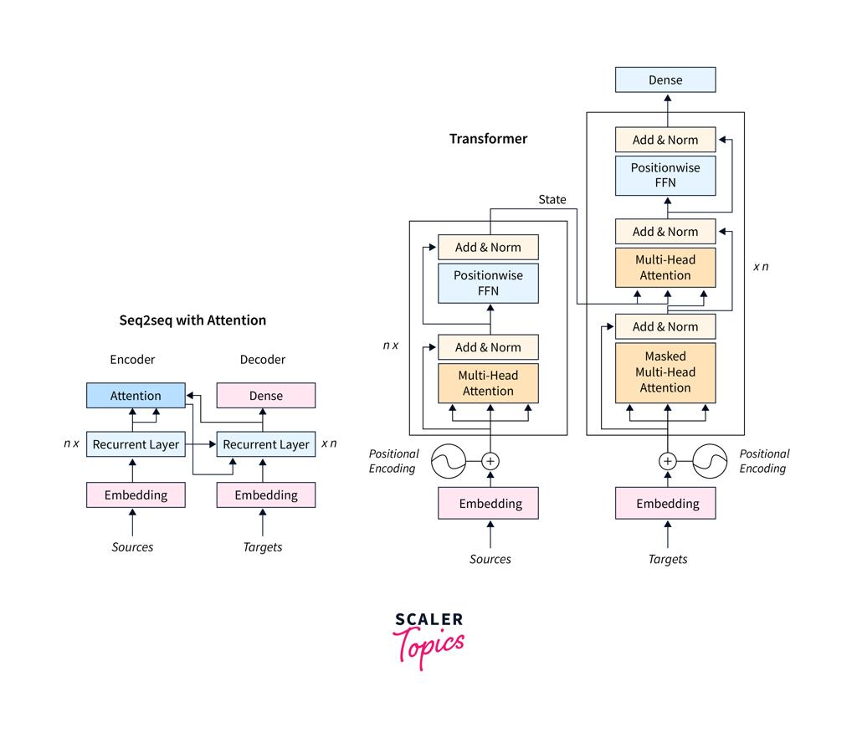
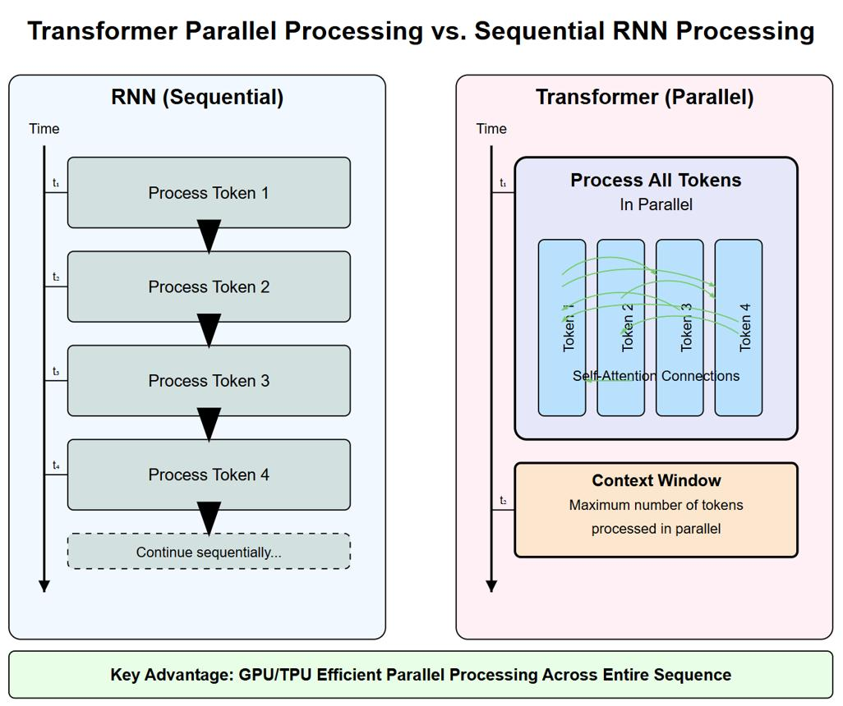
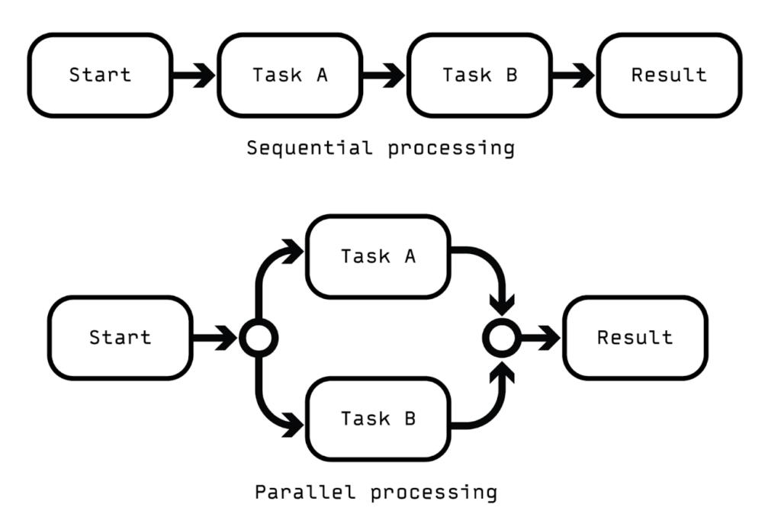
What it means
Transformers process all tokens at the same time, not one by one.
Comparison
Model | Processing Style
RNN | Sequential (slow)
Transformer | Parallel (fast)
Why it matters
- Faster training
- Handles large data efficiently
- Enables scaling to billions of parameters

